Index
1. Intro
1.1 Purpose
1.2 Scope
1.3 Definitions & Acronyms
2. References
3. Decomposition
3.1 Module Decomposition
3.1.1 Module 1 – SceneGraph
3.1.2 Module 2 - GUI
3.1.3 Module 3 - Rendering
3.1.4 Module 4 - Input
3.1.5 Module 5 - StateManagement
…
3.2 Concurrent Process Description
4. Dependency Description
4.1. Inter-module Dependencies
4.2. Inter-process Dependencies
4.3. Data Dependencies
5. Interface Descriptions
5.1 Module Interface
5.1.1 Module 1
…
5.2. Procedure Interface
…
6. Detailed Design
6.1. Module Detailed Description
6.1.1. …
6.2. Data Detailed Design
6.2.1. Data Entity 1
…
1. Intro *

This document describes the design of the Ragade’s Cube game. Specifically, the game is comprised of four distinct modules – the engine, the game logic, networking, and the AI.

1.1 Purpose *
The purpose of this design document is to provide a detailed design of all game components for the Ragade’s Cube project.

1.2 Scope *
This document is intended to show the partitioning between the various entities in the game and their hierarchical relationships. This document also defines the interfaces that the various designers, programmers, and testers will need to understand in order to use the system. Lastly, this document shall describe the detailed design of each entity within the game.

1.3 Definitions & Acronyms *
.NET –
AI –
Camera –
Cubelet –
Engine –
Facelet –
GUI –
Picking –
Rendering –
State –
Transformation –
XNA –
2. References *

3. Decomposition *
The engine is broken down into five separate components. These components include SceneGraph, GUI, Rendering, Input, and StateManagement.
The SceneGraph module allows graphical elements to be arranged hierarchically.
The GUI module is responsible for managing user interaction with the graphical elements of the game engine.
The Rendering module is responsible for correctly displaying graphical elements on the screen.
The Input module handles events from local input devices such as mouse, keyboard, and gamepad.
The StateManagement module manages specific game states.

3.1 Module Decomposition *
Please give me a description later.

3.1.1 Module 1 - Engine *
The game engine includes the components that are being pre-packaged in a manner that could later be used for general game creation. The engine is responsible for handling local user input, maintaining separate and mutually-exclusive game states, graphics rendering, and scene graph management.

3.1.2 Module 2 – Game Logic *
The game logic module is designed to control the game play for the Ragade’s Cube game. The game logic is responsible for loading game assets and initializing data structures within the game engine. This is a critical module because it defines all of the functionality that the game will provide for the user.

3.1.3 Module 3 - Networking *
The networking module provides the Ragade’s Cube game with multiplayer support across a network connection. The networking capability is provided through a client-server architecture for up to four concurrent connections per game session on the server.

3.1.4 Module 4 - AI *
The AI module provides an alternate user within the game play. The AI user has the ability to autonomously solve the Rubik’s cube with varying levels of skill.

3.2 Concurrent Process Description *
The game engine runs in a single-process loop, and thus contains no concurrent processes.
4. Dependency Description *
This section of the document describes the dependencies that occur within the Ragade’s Cube Game.

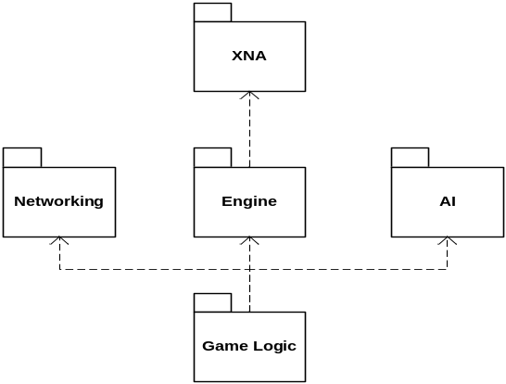4.1. Inter-module Dependencies *

See Diagram.

4.2. Inter-process Dependencies *
The game engine and the game logic run in a single-process loop, and thus contain no concurrent processes between them.
Networking, on the other hand, does run in separate threads. For each client attached to the game session, a new server connection thread is created. The data transmitted over the network is sent and read by this thread, which in turn communicates with the game logic.
AI also runs on a separate thread. This thread is used to communicate to the game engine the AI player’s next move, determined at game creation.

4.3. Data Dependencies *
The 3d cubelet and facelet models are generated at runtime. Each facelet model is attached to one side of its cubelet, and must not be larger than that cubelet to prevent excess occlusion.
During a multiplayer game using the networking module, messages will be communicated between both the client and the server in order to communicate each of the other connected game session clients. The messages that are sent will communicate each user’s moves performed on their local cube.
5. Interface Descriptions *

5.1 Module Interface *

5.1.1 Module 1 - Engine *
The engine provides a graphical representation of the state of the game demanded by the Game Logic. It also interprets the user input required for the Game Logic.
• Camera
• CameraManager
• Node
• Spatial
• Input Manager
• State Manager
• IWatcher
• Keyboard Event
• Mouse Event
• Gamepad Event
• Directional Light
• Render Manager
• Game State
• State Manager
• IGUIObject
• Pane
• Control
• Button
• Checkbox
• Image
• RadioButton
• RadioChannel
• Label
• ListBox
• GUIManager
• Picking
…

5.2 Procedure Interface *

…

6. Detailed Design *

6.1. Engine

6.1. Module Detailed Description *

6.1.1. Engine

6,1.1.1 Module 1 – SceneGraph
The SceneGraph module allows graphical elements to be arranged hierarchically. Graphical elements can be attached to other graphical elements; the position of each element in absolute space is determined by its relative position to its parent.
The SceneGraph module provides the time-oriented animation updating of each graphical element.

6.1.1.2 Module 2 - GUI *
The GUI module is responsible for managing user interaction with the graphical elements of the game engine. A manager is responsible for propagating user input events to specific GUI-derived objects.

6.1.1.3 Module 3 - Rendering *
The Rendering module is responsible for correctly displaying graphical elements on the screen. A singleton render manager provides an interface for displaying objects within the SceneGraph using an active camera defined by a camera manager. The render manager provides various default effects for the object being rendered, including four directional lights, texture mapping, and material specification.

6.1.1.4 Module 4 - Input *
The Input module handles simultaneous events from local input devices such as mouse, keyboard, and gamepad. It routinely checks the state of each device and raises events.

6.1.1.5 Module 5 - StateManagement *
The StateManagement module manages specific game states. States define specific logic for different phases of the game. States may have different input schemes, graphical elements, and game logic, but have some similar functionalities. The GameState class allows for specification and defines common functionality.
The state manager service manages states in a stack and the transitions between them.

6.2 Data Detailed Design *

6.2.1 Data Entity 1 *

…

